Spring Security

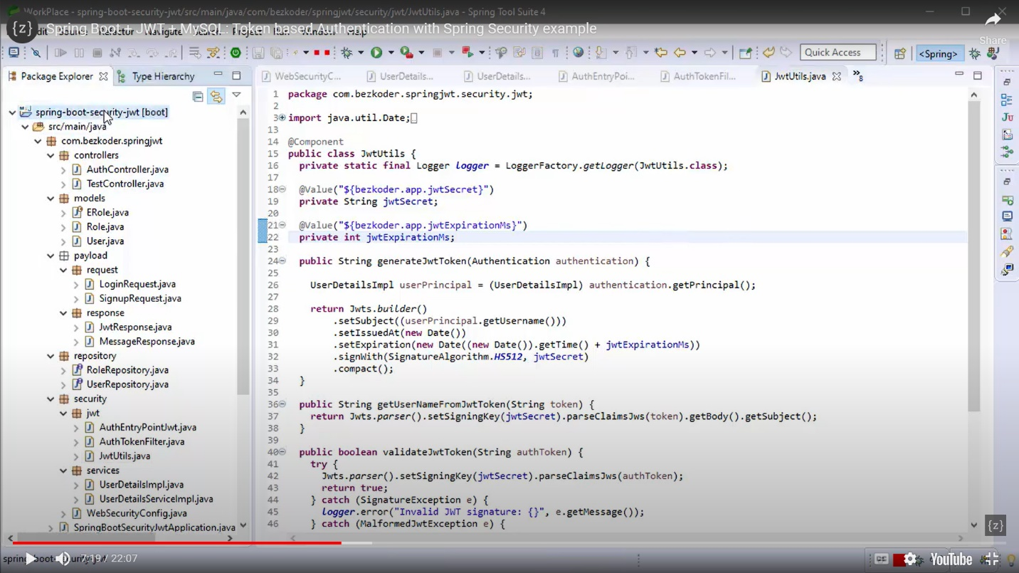

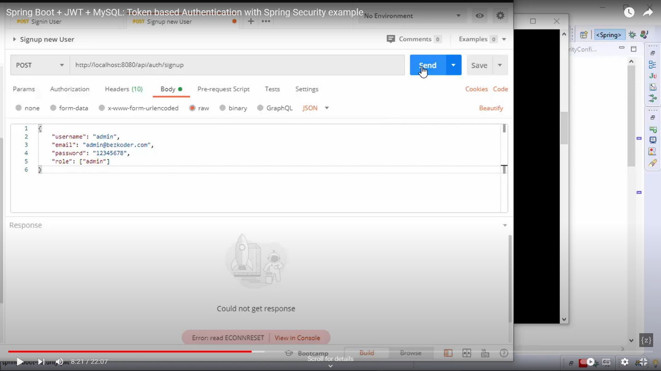

User sign in :

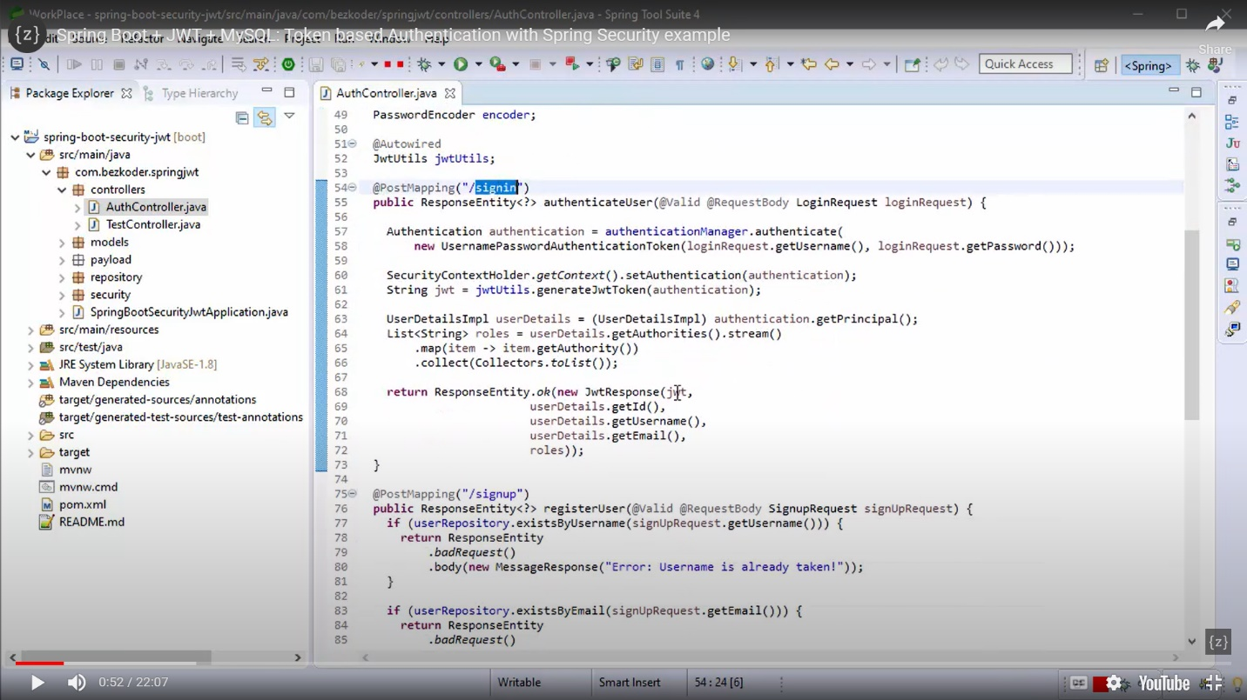

<https://medium.com/javarevisited/crack-your-backend-development-interview-must-know-questions-and-topics-7bf2cc066fdc>

2PC 2phase commit:

